Bellow is a screen shot of the text inside of “student_record” before running the program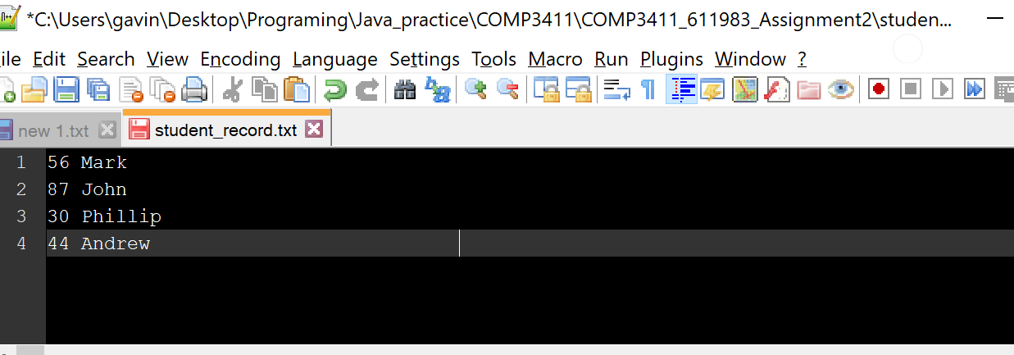

Bellow is a screenshot after running the program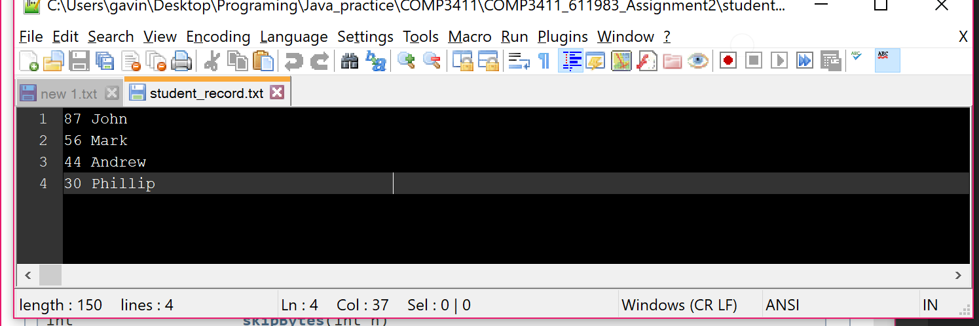

Bellow is another example of text before running the program

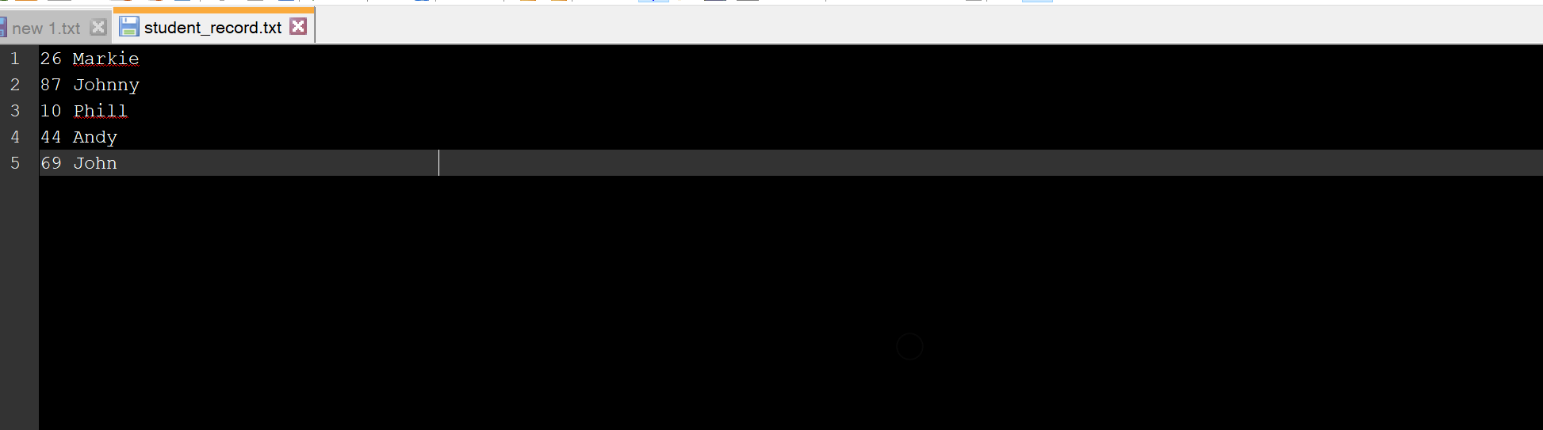

Finally this is the results of the program

